**Group 7** Carlos Guttormsen, 245621

Yuan Qi, 267957

**Fourth Iteration Report**

This is group seven’s fourth iteration report for the Introduction to Industrial Informatics course work. In this report, went through the diagrams from last iterations and decided to create a new diagram to illustrate our project’s processes unified. We also made the UI and the application server with the simulator and the knowledge base which contains the components of the FASTory manufacturing line and their properties as well.

**Unified Process Diagram**

For this iteration we created a unified process diagram to tie the different aspects of our project work together. This diagram is illustrated in the picture 1 below.

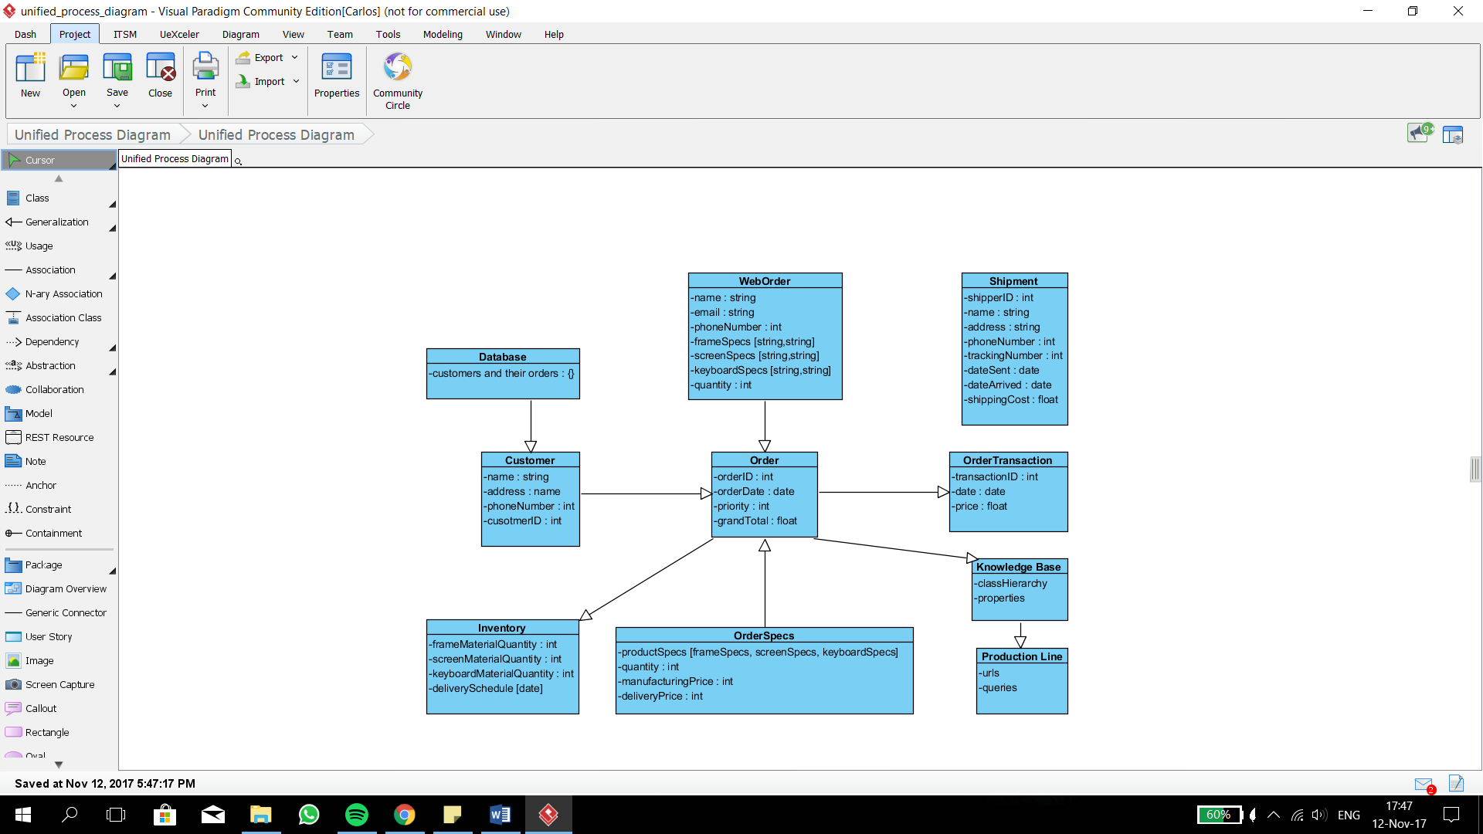

**Picture 1.** Unified Process Diagram

In this diagram we have represented how different parts in our project are dependent of each other in order to process a customer’s order from start to finish.

**Web Server UI and its Code**

The UI we developed for our project is illustrated in the picture 2 below. It has the fields for obtaining buyer information and of course the specifications for the buyer’s order.

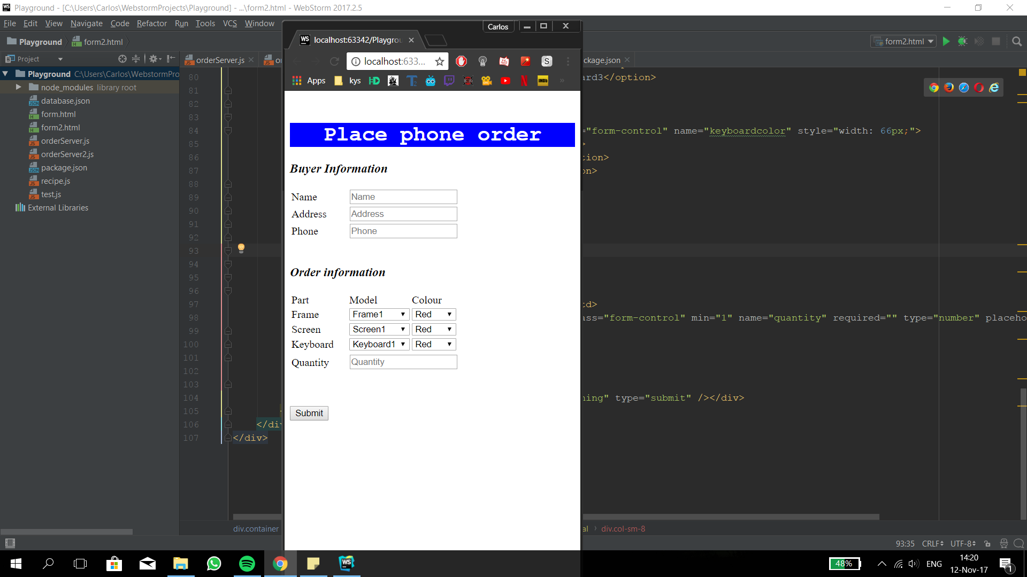

**Picture 2.** Web Server UI

The order information fields are the main part of the UI. According to the instructions for this project, the phone consists of three different parts that can be altered; the frame, the screen and the keyboard. Each part can be specified to be of a certain color or of a certain model. Finally, the last part of the order is the quantity. After all the information has been filled the customer can click the "Submit" button. At this instance we fetch all the information and store it in our JSON type database for further usage.

The main code can be found in the “iii_project.js” file in which we created a local server and connected it with the UI and subscribed to all the events in the simulator. We can get the response from the simulator when the event is triggered. Also, we can get the information about the status of any conveyor but the step we need to do is to connect the knowledge base with our server so that we can do the query properly. The specific explanations can be found in the comments of the “.js” file.

**Knowledge Base**

For this Iteration, we created the first version of our knowledge base using the tool Olingvo. With this program, we defined the class hierarchy, the individuals each entity holds within and the properties they have. A collection of the class hierarchy and the properties used in our knowledge base are represented in the picture 3 below.

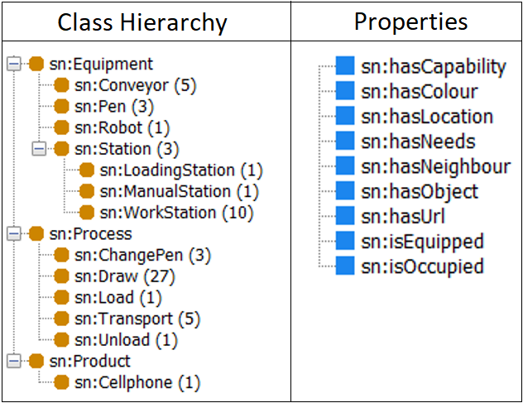

**Picture 3.** Representation of the Knowledge Base

The numbers behind pieces of equipment, processes and products in the class hierarchy portion of the picture 3 represent the quantity of each thing. For example, we have three different types of stations in our manufacturing line which are named accordingly in the knowledge base: LoadingStation, ManualStation and WorkStation. Taking the same example further we can also say what types of properties each station has. For example, in our case the individuals of the class WorkStation have the property hasObject which describes what objects a class has. In this instance those objects (for the WorkStation) would be Conveyor and Robot.

Each class can have various individuals and these individuals can have various properties.